Use English units consistently throughout

1. Select a species
   1. **Display basic properties of that species**
      1. Brief Description (See Chapter 1, p3-34)
      2. Physical constants
         1. $G_{b}$- Specific Gravity Green and 12% Moisture content (Table 4-3b)
         2. $ρ$- Density at a specified Moisture Content (default = 20%, changeable by user) for calculation see page 50

M = Percentage (20% default), but changeable by users







* + - 1. - Coefficients for Dimensional Change (Table 12-5)
  1. **Moisture driven Dimensional Changes**Separately for radial and tangential dimensions, initial and final moisture content, display $\frac{\text{ΔD}}{{\text{D}}_{\text{l}}}$  
        
     calculated per equation 12-2.



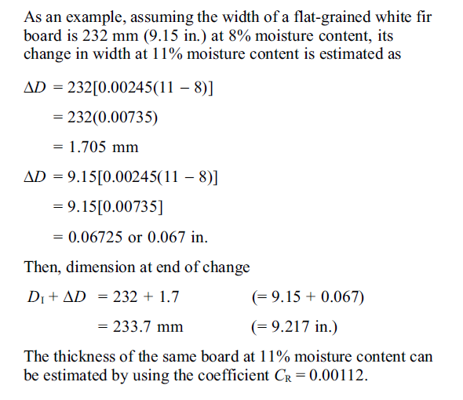

* 1. **Beam Deflections**  
     Use equation 8-2, only for rectangular cross section beams.



